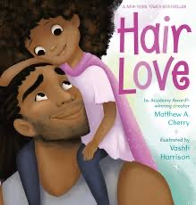
HAIR LOVE By Matthew A. Cherry
Zuri's hair has a mind of its own. It kinks, coils, and curls every which way. Zuri knows it's beautiful. When Daddy steps in to style it for an extra special occasion, he has a lot to learn. But he LOVES his Zuri, and he'll do anything to make her -- and her hair -- happy. Tender and empowering, Hair Love is an ode to loving your natural hair -- and a celebration of daddies and daughters everywhere.

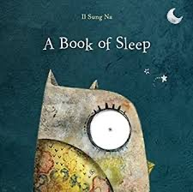
A BOOK OF SLEEP by Il Sung Na
With a spare, soothing text and beautifully rich and textured illustrations of a starry night, this is the perfect “book of sleep.” Join the owl on his moonlit journey as he watches all the other animals settle in for the night: some sleep standing up, while some sleep on the move! Some sleep peacefully alone, while others sleep all together, huddled close.

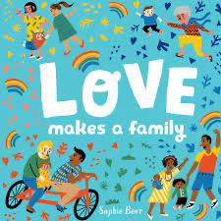
LOVE MAKES A FAMILY by Sophie Beer
Love is baking a special cake. Love is lending a helping hand. Love is reading one more book. In this exuberant board book, many different families are shown in happy activity, from an early-morning wake-up to a kiss before bed. Whether a child has two moms, two dads, one parent, or one of each, this simple preschool read-aloud demonstrates that what's most important in each family's life is the love the family members share.

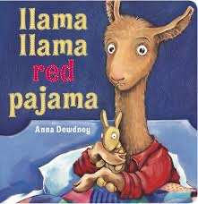
LLAMA LLAMA RED PAJAMA by Anna Dewdney
Llama Llama’s tale of nighttime drama has charmed readers for over a decade and makes an ideal story for bedtime reading. With this board book edition, Anna Dewdney’s infectious rhyming text and expressive artwork are available to the youngest readers. Children will relate to Baby Llama's need for comfort, as much as parents will appreciate Mama Llama's reassuring message.

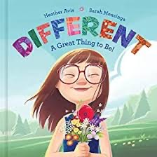
DIFFERENT – A GREAT THING TO BE! By Heather Avis
Macy is a girl who’s a lot like you and me, but she's also quite different, which is a great thing to be. With kindness, grace, and bravery, Macy finds her place in the world, bringing beauty and laughter wherever she goes and leading others to find delight in the unique design of every person.

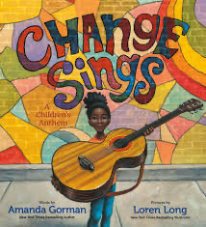
CHANGE SINGS by Amanda Gorman
In this stirring, much-anticipated picture book by presidential inaugural poet and activist Amanda Gorman, anything is possible when our voices join together. As a young girl leads a cast of characters on a musical journey, they learn that they have the power to make changes—big or small—in the world, in their communities, and in most importantly, in themselves.

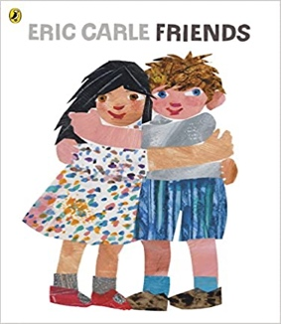
FRIENDS by Eric Carle
When a best friend moves away, it can be painful for the child who is left behind. But the spunky boy in this upbeat story makes up his mind to find his missing playmate. Friends tells a story alive with love and perseverance, brightened with vibrant art and Eric Carle's trademark fostering of imagination.

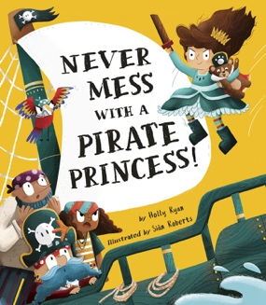
NEVER MESS WITH A PIRATE PRINCESS! By Holly Ryan
Princess Prudence loves all of her stuffed animals, but her favorite is Little Ted, her royal teddy bear. She takes him wherever she goes. One afternoon, she and Little Ted are taking a nap in the forest when suddenly, a pirate appears and steals him! The pirate takes the teddy bear to his pirate ship. Princess Prue is determined to get him back—but can she defeat a ship full of pirates to rescue her beloved teddy bear?

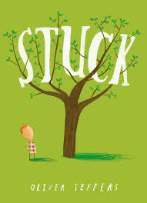
STUCK by Oliver Jeffers
When Floyd's kite gets stuck in a tree, he's determined to get it out. But how? Well, by knocking it down with his shoe, of course. But strangely enough, it too gets stuck. And the only logical course of action . . . is to throw his other shoe. Only now it's stuck! Surely there must be something he can use to get his kite unstuck. An orangutan? A boat? His front door? Yes, yes, and yes. And that's only the beginning. Stuck is Oliver Jeffers' most absurdly funny story since The Incredible Book-Eating Boy. Childlike in concept and vibrantly illustrated as only Oliver Jeffers could, here is a picture book worth rescuing from any tree.

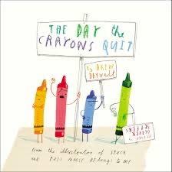
THE DAY THE CRAYONS QUIT by Drew Daywalt
Poor Duncan just wants to color. But when he opens his box of crayons, he finds only letters, all saying the same thing: His crayons have had enough! They quit! Blue crayon needs a break from coloring all those bodies of water. Black crayon wants to be used for more than just outlining. And Orange and Yellow are no longer speaking—each believes he is the true color of the sun. What can Duncan possibly do to appease all of the crayons and get them back to doing what they do best?

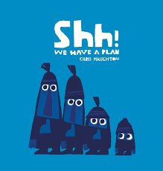
SHH! WE HAVE A PLAN by Chris Haughton
Four friends creep through the woods, and what do they spot? An exquisite bird high in a tree! “Hello birdie,” waves one. “Shh! We have a plan,” hush the others. They stealthily make their advance, nets in the air. Ready one, ready two, ready three, and go! But as one comically foiled plan follows another, it soon becomes clear that their quiet, observant companion, hand outstretched, has a far better idea.

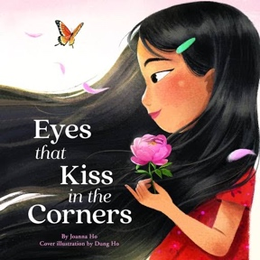
EYES THAT KISS IN THE CORNERS by Joanna Ho
A young Asian girl notices that her eyes look different from her peers'. They have big, round eyes and long lashes. She realizes that her eyes are like her mother’s, her grandmother's, and her little sister's. They have eyes that kiss in the corners and glow like warm tea, crinkle into crescent moons, and are filled with stories of the past and hope for the future.

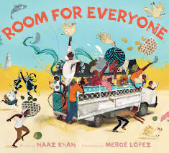
ROOM FOR EVERYONE by Naaz Khan
The dala dala rumbles and roars as Musa and Dada drive off to the shore—but the bus stops for multiple detours: “Do you need a ride? It’s hotter than peppers out there in the sun! Come in, there’s room for everyone!” One stop becomes two stops which soon becomes ten, and Musa wonders when it will end: “How can any more people get in? We’re already smushed like sardines in a tin!” But there's always room for one more, if you make the room, which is the heartwarming take-away from this bouncy, joyous tale in rhyme.

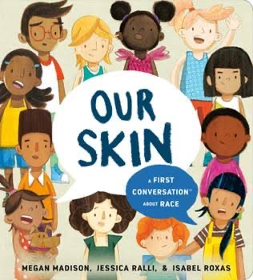
OUR SKIN: A FIRST CONVERSATION ABOUT RACE by Megan Madison
While young children are avid observers and questioners of their world, adults often shut down or postpone conversations on complicated topics because it's hard to know where to begin. Research shows that talking about issues like race and gender from the age of two not only helps children understand what they see, but also increases self-awareness, self-esteem, and allows them to recognize and confront things that are unfair, like discrimination and prejudice.

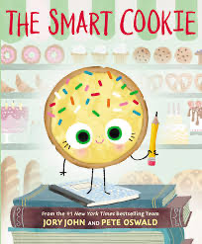
THE SMART COOKIE by Jory John
This cookie has never felt like a smart cookie no matter how hard she tries, especially in comparison to all the clever cupcakes and brilliant rolls in the bakery. Will a dash of creativity and a sprinkle of confidence be enough to help her learn that perfect scores and having all the answers aren’t the only ingredients for intelligence?

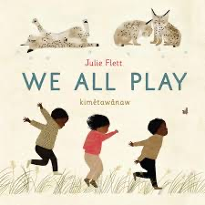
WE ALL PLAY by Julie Flett
This wonderful book celebrates playtime and the connection between children and the natural world. Beautiful illustrations show:
- birds who chase and chirp!
- bears who wiggle and wobble!
- owls who peek and peep! and a diverse group of kids who love to do the same, shouting: We play too! / kimêtawânaw mîna

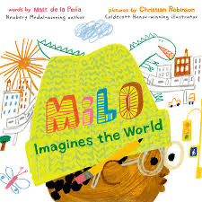
MILO IMAGINES THE WORLD by Matt de la Pena
Milo is on a long subway ride with his older sister. To pass the time, he studies the faces around him and makes pictures of their lives. There's the whiskered man with the crossword puzzle; Milo imagines him playing solitaire in a cluttered apartment full of pets. There's the wedding-dressed woman with a little dog peeking out of her handbag; Milo imagines her in a grand cathedral ceremony. And then there's the boy in the suit with the bright white sneakers; Milo imagines him arriving home to a castle with a drawbridge and a butler. But when the boy in the suit gets off on the same stop as Milo--walking the same path, going to the exact same place--Milo realizes that you can't really know anyone just by looking at them.

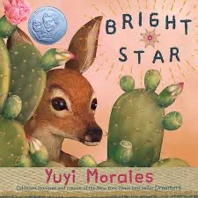
BRIGHT STAR by Yuyi Morales
With the combination of powerful, spare language and sumptuous, complex imagery characteristic of her work, Yuyi Morales weaves the tale of a fawn making her way through a landscape that is dangerous, beautiful—and full of potential. A gentle voice urges her onward, to face her fears and challenge the obstacles that seek to hold her back.

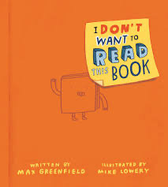
I DON’T WANT TO READ THIS BOOK by Max Greenfield
Words, sentences, and even worse, paragraphs fill up books. Ugh! So what's a reluctant reader to do? Actor Max Greenfield (New Girl) and New York Timesbestselling illustrator Mike Lowery bring the energy and laugh-out-loud fun out for every child (and parent) who thinks they don’t want to read a book. Joining the ranks of favorites like The Book With No Pictures and The Serious Goose, this clever and playful read-aloud breaks the fourth wall and will have all readers coming back for laughs again and again!

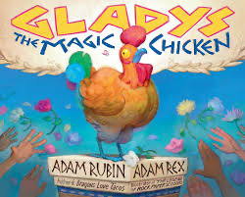
GLADYS THE MAGIC CHICKEN by Adam Rubin
Gladys the chicken must be magic. After all, for everyone who encounters her, a wish is granted. The Shepherd Boy wishes to be beautiful, the Brave Swordsman wishes to join the Royal Guard, the Purple Pooh-bah wishes for his only daughter to be happy, and the Learned Princess wishes to escape the palace. And one by one, each of these wishes comes true. But . . . is Gladys really magic? Or is everyone making their own fortune? Either way, it adds up to one heck of an adventure for a chicken named Gladys. Blending a classic storybook feel with a modern sense of humor, this side-splitting read aloud is perfect for anyone who wishes to see magic in the world—even if they are only looking at a chicken.

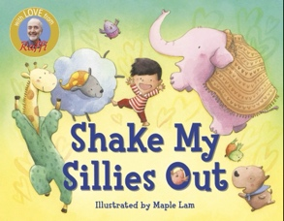
SHAKE MY SILLIES OUT by Raffi
Shake, clap, jump, and wiggle your way through this classic Raffi sing-along book!
Join a group of happy campers on a fun moonlit night in beloved Raffi Song to Read. The rhythm, rhyme, and repetition of singing support and encourage speech and listening skills, and lay the foundations for later reading.

